Module 6: S3 Bucket Versioning Assignment
Problem Statement:
You work for XYZ Corporation. Their application requires a storage service that can store files and publicly share them if required. Implement S3 for the same.
Tasks To Be Performed:
1. Enable versioning for the bucket created in task 1.
2. Re-upload any 2 files already uploaded to verify if versioning works.

1.Versioning is not enabled earlier for the bucket assignment-01-june:
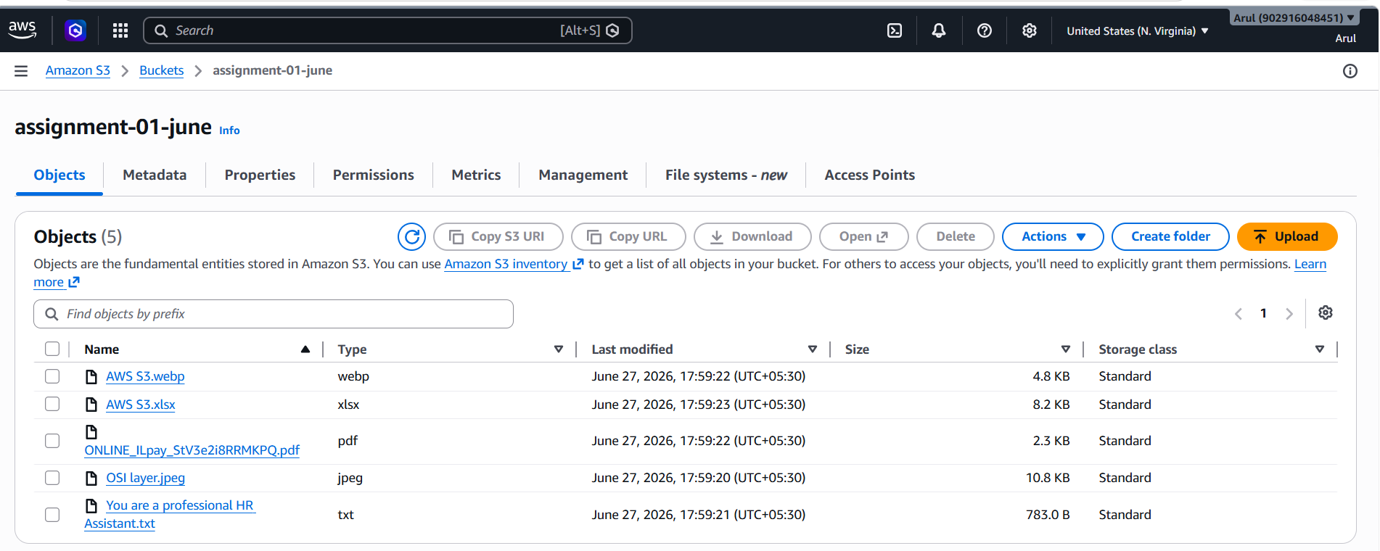

2. Go to Bucket Properties Bucket Versioning Edit Enable Save.
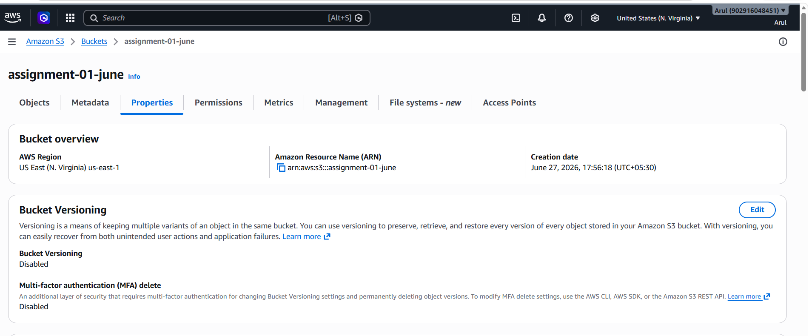

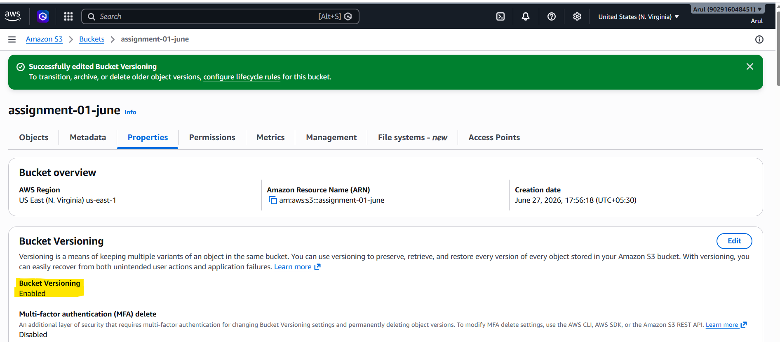

3. As highlighted, Versioning is enabled now:
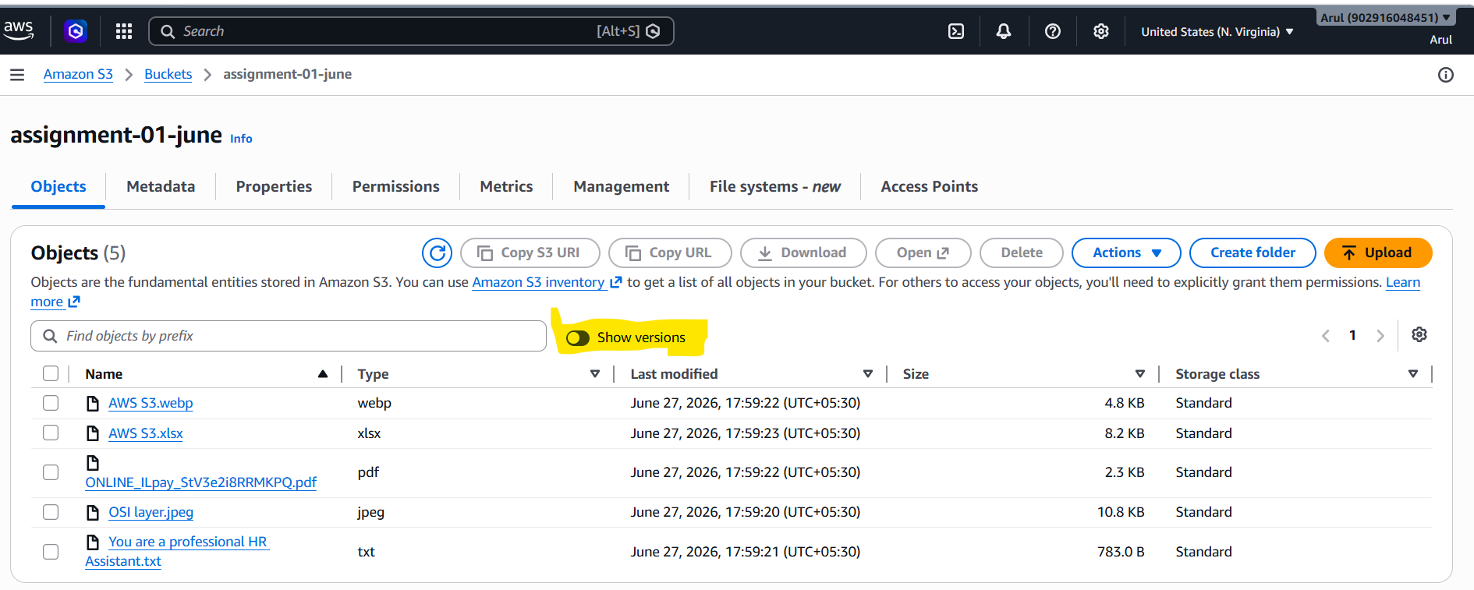

4. For old objects, version ID is null.
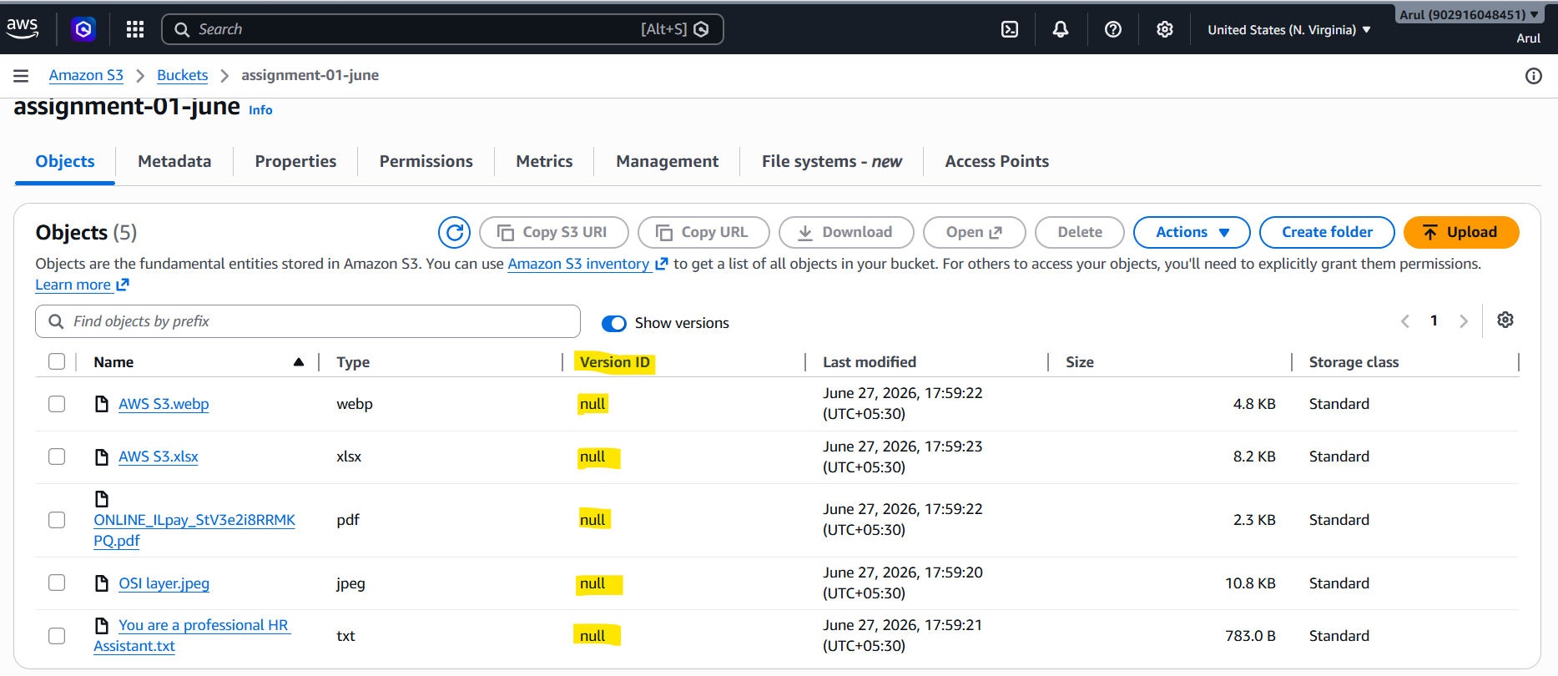
5. Re-uploading two objects:
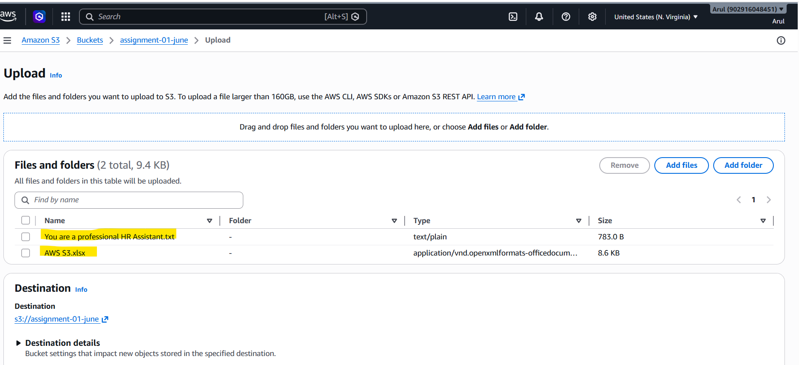

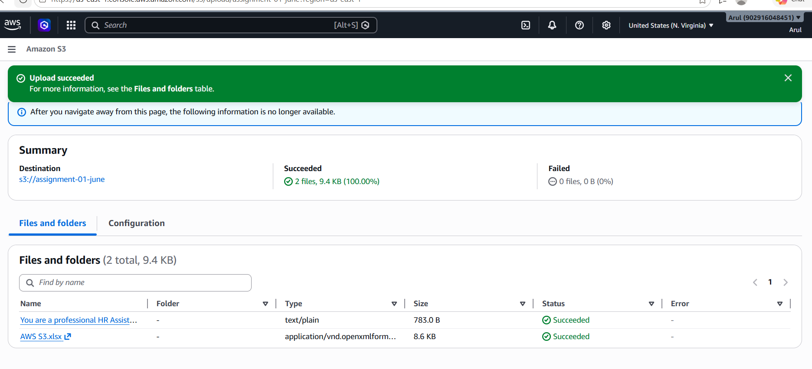

6: Version ID with new timestamp is visible as highlighted:
